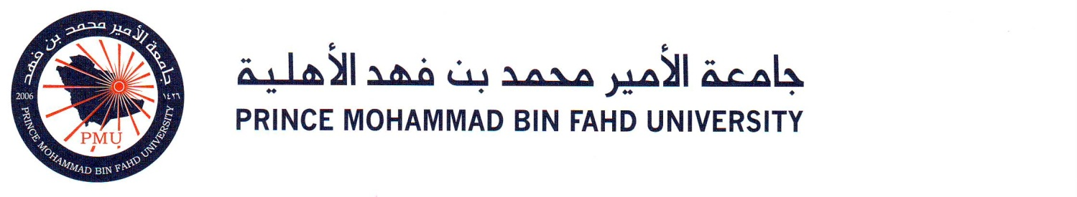

ASSE 2111: Learning Outcome Assessment 1

Assignment: About Me and Professional Goals

Student Name: Nasser Alghadeeri

Student ID: 202201322

LAB Section: 135
Semester and Year: Fall 2025/2026

About Me

My name is Nasser. I am third year student at PMU; I joined the university back in 2022 for the purpose of learning and developing specially in the engineering field, I specialize in mechanical engineering of which I have loved ever since I was a little kid.
What really got me into loving the engineering world is muscle cars! I loved how well shaped they are as well as of course the loud noise they make so, I started to look into the engineering aspects and the different components of the muscle cars and how different they are from other types of cars.
After graduating high school, I joined Aramco as a trainee in which I have studied mathematics, english as well as many other subjects about my work some of which are pipe fitting and oil and gas operation, which was associated heavily with engineering so, I can confidentially say that I am pretty well informed and educated regarding the engineering aspects in my work before actually doing it as an employee
What has really sealed the deal for me and made me really want to study mechanical engineering and engineering in general is working with engineers after graduating and signing the contract with Aramco. My work is really and heavily associated with engineering so basically every day I communicate with engineers such as petroleum engineers, as well as mechanical engineers about the issues we encounter in which they always have a solution for timely and safely.
Today, and after three years of continuous learning in PMU I can confidently say that I will be, and I will try my hardest to always be the best of the best version of myself, PMU has taught me important aspects in the professional world which will be helpful as a future and current leader.

Professional Goals

Short-terms goals: as a student I always aim to leave the classroom with new knowledge and experiences, each class offers lots of opportunities and it is my duty as a mechanical engineering student to be able to have the right skills that allows me to take on these opportunities. I aim to find the opportunities that makes me apply what I have learned at the university in my professional world as an oil and gas operation coordinator in Saudi Aramco, I have taken multiple courses in the university that was extremely helpful in my work, such as critical thinking, leadership as well as professional development these particular courses helped me grow as a leader in my current field. One of my short-term goals is finding the missing components that could make my workplace better, although it is not quite easy to do so applying what I have learned in the university would make this goal and journey of mine a little more easier, I am not trying to find the easy way to do things, however finding the opportunities to apply what I have learned in the previous classes made the goal more clear. Another short term goal of mine is to excel academically, it should be the main priority for any student to be able to pass each class with the highest grade possible, doing that means that I have to be discipline with attending the classes on time and participating with the professor studying every day and submitting my assignments on time as well as trying to help the other student because I believe when you do a good deed it will eventually comes back to you.

Long-term goals: In the long run, there are multiple goals in my mind one of which is building my own company that specialize in engineering consulting and development. Building and fixing automobiles has been something I enjoy so, another goal of mine is opening a workshop that is specialize in fixing, building, upgrading automobiles, specially, muscle cars, I aim to be your number one trusted workshop for anything related to the automobile world. Another thing that I am determined to achieve is getting my master's degree and then my PhD, I aim to keep learning and developing for as long as I live because I believe no human being can learn too much or develop enough. There is always room for improvement. Another thing I have in my mind as a goal is becoming a professional and skilled mechanical engineer that can make the future a better place, right now we have a lot of technologies that is designed to make the world better for everyone imagine the word after 50 years could you imagine what we could achieve? The cars, airplanes, ships, as well as the trains all have gotten futuristic in the last 15 years so just imagine the technology that we as engineers will develop in 50, I aim to be a big part of this change I will try my hardest to make the word better.

